NEWSLETTER

Bowden Street,
Kersbrook SA 5231

Tel: 08 8389 3068 Fax: 08 8389 3346

Email: dl.0204.admin@schools.sa.edu.au

Number 6 | Friday 6th April, 2018

Dates To Remember  Term 1 ends  Friday 13th April 2pm  Pupil Free Day  Term 2 – Week 1  Monday 30 April  Right Bite  Daily fruit and lunch on Thursdays  Japanese Dates to Remember  29th April – Emperor’s birthday  5th May – Kodomo no hi (Children’s day)  In This Issue  Principal’s Message  Room 3 Class Work  Warrawong Visit  Sporting Schools Free T Shirt  Green Shed  Entertainment Booklet  Calendar   |   Dear Students, Parents and Caregivers,  It is with great excitement that I am able to announce that our new website will be available early next term.  More information soon!  Term 1 has proved to be a busy start to the year with great learning happening in all of our classes. This year sees the great work we have been doing over the last two years in Mathematics being maintained while we focus on Reading and Literacy improvements across our school. The results so far are very encouraging as we support and challenge each student to do his or her very best.  In this newsletter we welcome and farewell our students from Thailand. We have had Pun-Pun, Toey, Ta-Ta and Un-Chi-Sa with us since their arrival on Sunday 25th March. They will leave at 6.30am on Tuesday 10th April. Their host families have provided some wonderful opportunities for them and I am sure they will return to Thailand with many wonderful memories and stories to share about their experience in Australia. The opportunity to have international students at our school has enormous benefits for everyone involved and it is clear that all of our students have gained in one way or another from the experience.  The end of this term is time for another farewell. Aleena Arnold has been our OSHC Director this term and will not be continuing in this position next term. Aleena will continue as an SSO in classes in the mornings. I will advise when further staffing information is available.  We have had an ongoing problem this year with dog poo on our oval. We are very happy to share our lovely oval with the community and encourage everyone to use it after hours and on weekends. The only request we have is that pet owners clean up after their pets.  A ring was found in the bark after school on Thursday 29th March, the day before Easter Friday. If you know who this belongs to please ask them to contact us.  Jill Gurner  Principal
Warrawong
Warrawong’s visit on Tuesday 3rd April reminded us that Australia’s wildlife is unique. As we live in a biological hotspot, it is important that we know how to live alongside our wildlife so that it can survive.

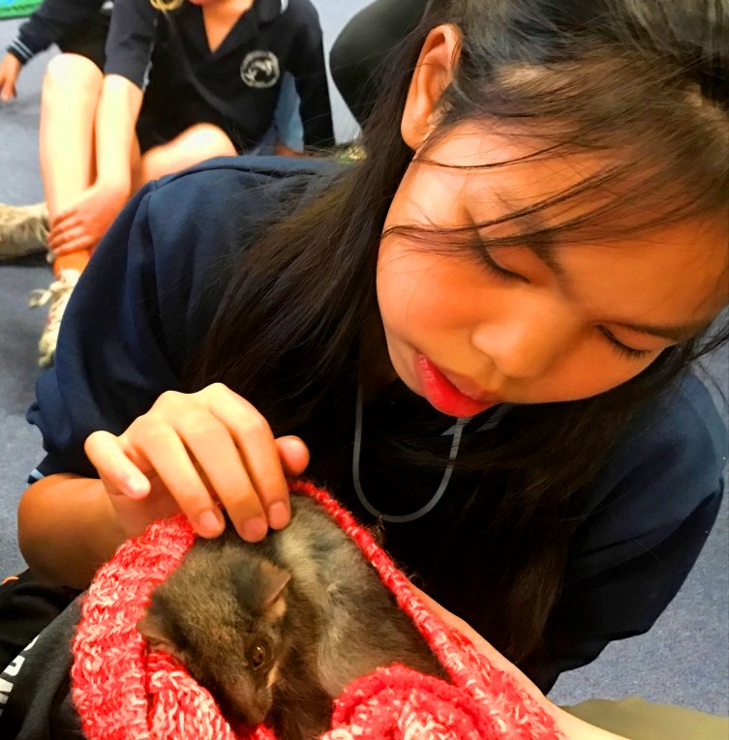
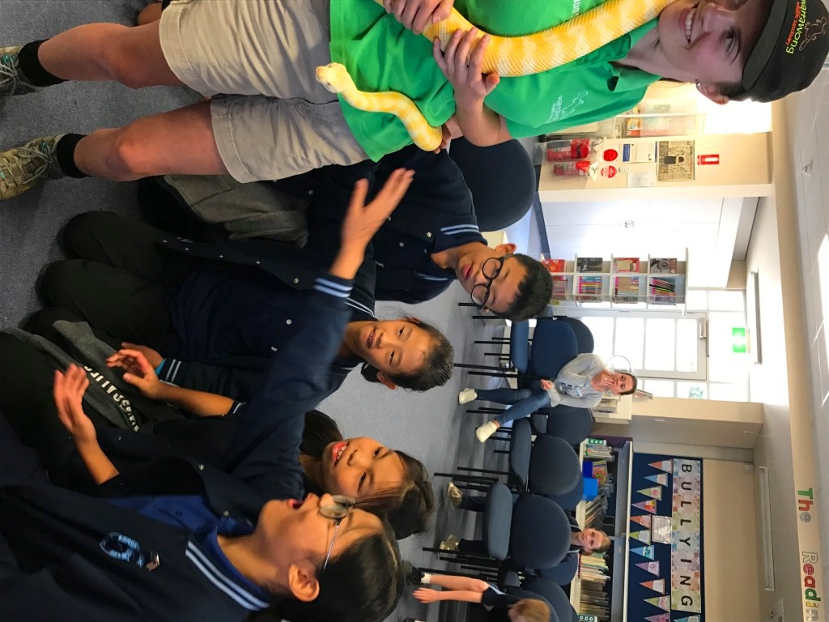
Images clockwise: Toey looks at the Sugar Glider; the beautiful yellow Albino Python admired by Pun-Pun, Toey, Ta-Ta and Un-Chi-Sa; Kalan makes friends with an Olive Python; Weasley the Bettong. There were many Bettongs around Kersbrook before it became impossible for them to live with the introduced predators, especially cats and foxes.

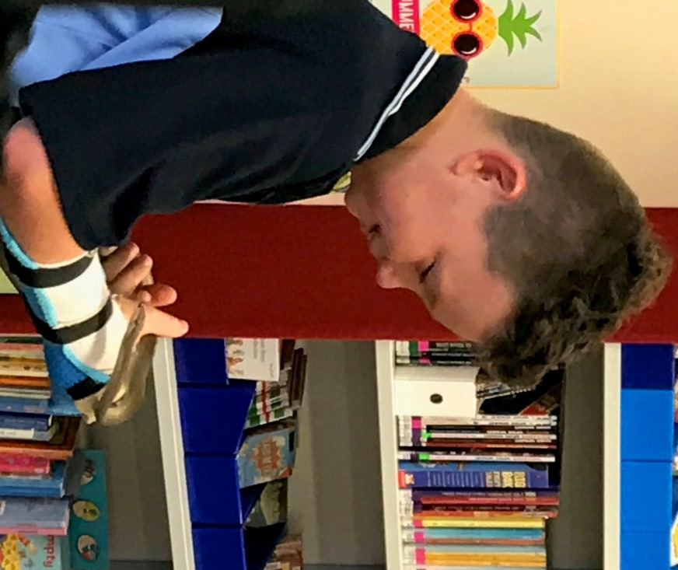

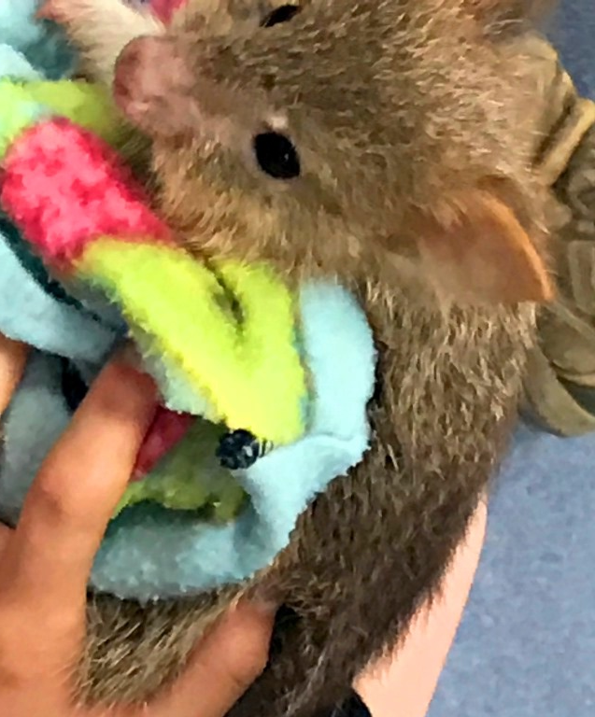

Sporting Schools Tennis – Free T-Shirt

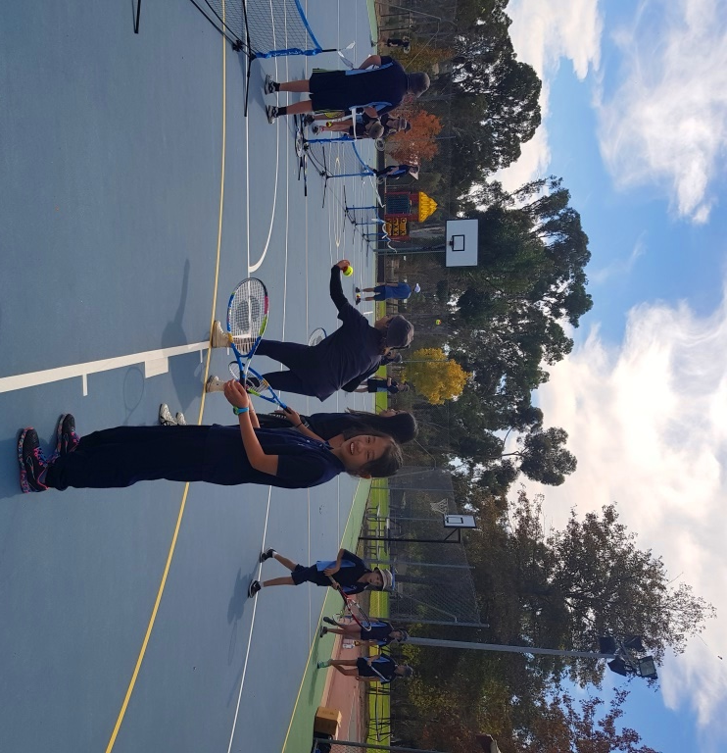
We have been very fortunate to have Craig Palfrey coach tennis for 4 days over the past two weeks.

Thank you to Sporting Schools for funding the Tennis program via a grant of $1700 which has provided coaching and also nets, raquets and equipment.

It has been great fun and some students who have never played have enjoyed the game.

Please get your free Sporting Schools T-Shirt – you just need to order on-line and Craig will bring it in. Go to www.hotshots.tennis.com.au/register
Select Birdwood as the venue and Craig’s name will come up and then select the size.

Green Shed


Along with the James’ family from Kersbrook, The Green Shed at 249 Kenton Valley Road Gumeracha have recently been very generous contributors to our Right Bite program. The Green Shed’s Frank and Rosemary Baldasso along with Mark Willington have been keeping us supplied with apples, nashi pears and delectable stone fruits. Our students have lots of variety to choose from and we would like to thank The Green Shed for their generosity and donations of produce. It is great to see our students eating healthy foods supplied at school. For produce from the Green Shed see: https://www.facebook.com/The-Green-Shed-217284301802418/

Entertainment Book

Pre-order to support Kersbrook Primary School!
We are raising funds for our School and you can help. Order the NEW 2018 | 2019 Entertainment Book or Entertainment Digital Membership and you will receive hundreds of valuable offers for everything you love to do, and you will also be supporting our School. PLUS, order now to receive over $150 of bonus Early Bird Offers (hurry, these sell out quickly).
SUPPORT US NOW.

"I love that I save the cost of the book within the first couple of voucher usages - so the rest is pure savings! Makes me get out and try new restaurants that I never would have considered and I'm saving money!” – Jacqui A



Kersbrook Primary School
Lynn Rawlings
08 83893068
dl.0204_admin@schools.sa.edu.au
THANK YOU FOR YOUR SUPPORT!

Calendar Term 1
TERM 1 2018
11 | Monday 9/4/18 | Tuesday 10/4/18 | Wed 11/4/18 | Thurs 12/4/18 | Friday 13/4/18
 |  | Thai students depart | Playgroup 9am | Right Bite Lunch | 2pm Pick Up
TERM 2
1 | Mon 30th April | Tues 1st May | Wed 2nd May | Thurs 3rd May | Friday 4th May
 | Pupil Free Day |  | Playgroup 9am | Right Bite Lunch
2 | Mon 7th May | Tues 8th May | Wed 9th May | Thurs 10th May | Fri 11th May
 | Start Smart Financial Literacy |  | Playgroup 9am | Right Bite Lunch | Mother’s Day Stall
3 | Mon 14th May | Tues 15th May | Wed 16th May | Thurs 17th May | Fri 18th May
 | Soccer |  | Playgroup 9.30am | Assembly  Right Bite Lunch | National Walk to School Safely Day
4 | Mon 21st May | Tues 22nd May | Wed 23rd May | Thurs 24th May | Fri 25th May
 | Soccer |  | Playgroup 9am  Nat Simultaneous Storytime | Right Bite Lunch
5 | Mon 28th May | Tues 29th May | Wed 30th May | Thurs 31st May | Fri 1st August
 | National Reconciliation Week  Soccer |  | Playgroup 9am | Right Bite Lunch
Gemini Netball Club Inc.

Gemini Netball Club wishes to advise that registrations are now open for NET SET GO program we are conducting.

Gemini Netball Club are also a SPORTS VOUCHER registered club so $50 for participants can be claimed. Answer yes to claiming sports voucher and answer all the questions relevant to claiming and the club will make claims.

NET SET GO Program on the following dates:
commencing Thursday 3rd May and each following Thursday night for
10 weeks ending Thursday July 5th 20187
NET program for 5-8 yrs of age
SET program for 8-10yrs of age

Time: 5.30pm to 6.30pm Fee: $110

Registration link! Copy and paste:
direct registration page please visit:
https://netball.resultsvault.com/common/pages/reg/welcome.aspx fl=1&type=6&id=41624&entityid=44079

Payment gateway is available at time of online registration. You can indicate offline
payment of fees. The fees can also be eft’d directly into club bank account.
GEMINI NETBALL CLUB INC. CBA ST AGNES
bsb: 065 149 a/c 1027 8034 use surname & nsg fees

CLUB WEBSITE:
www.gemini.sa.netball.com.au
For any assistance please ring Margaret 0414641063



